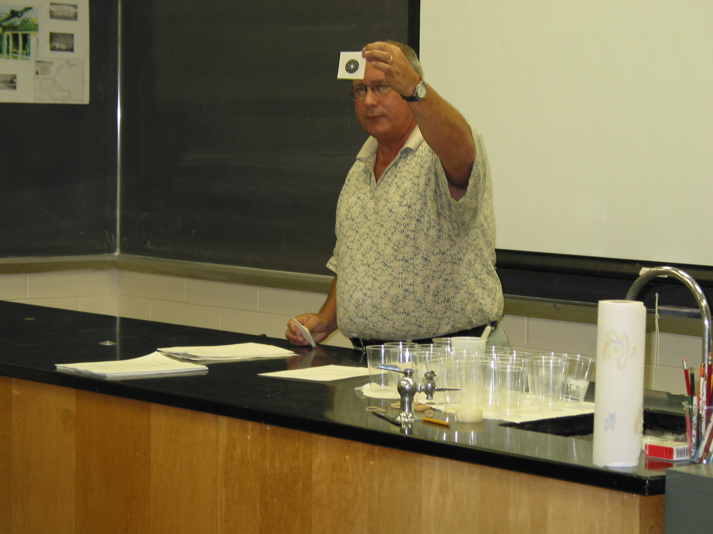

Instructor: Bill Natusch (2002 Science Teacher Workshop participant)

School District: East Side High School, Newark, NJ

Lesson Title: Radiation Concentration

Grade: Special Ed. 9

Subject: Comprehensive Science

Overview: Students will be able to learn the wonders of radiation and its sources. They will learn to distinguish between ionizing and non-ionizing radiation.

Materials and Resources:
- Index cards
- Foamtastic Mat 15” x 20”
- CD – computer for research
- Numerous charts displayed on classroom walls

Procedure:
After the students have been exposed to a couple lessons of chemistry and radiation, they will utilize this game called “radiation concentration,” which will encourage them to review the subject material that they have learned in class.

The game mimics the real television game of “Concentration.” The teacher will make game cards which are 2” x 3”. These cards will be placed in 20 matching cards on the table mat.

Students will work in pairs and one at a time will try to match up the question and answer with the cards.

As the learning process continues, the teacher can make up continuous questions and answer cards as students are learning each subject matter.

Listed below are some examples
Subject Property
Ionizing radiation | High energy levels, short wavelengths
Radioactivity | Energy in the form of waves of particles sent over a distance
Radioactive material | Material that gives off (emits) high energy ionizing radiation
Alpha, beta, gamma | Three types of ionizing radiation
Electron, proton, neutron | Parts of an atom
Gamma, x-rays | Can pass through the human body. Lead is used for protection
Beta radiation | Fast moving electrons. Can be stopped by a sheet of aluminum
Geiger counter | Tells us that radioactivity is present
Isotopes | Atoms with the same number of protons but different numbers of neutrons
The nucleus | The center of the atom
Alpha radiation | Little penetrating power. Positive electrical charge.

