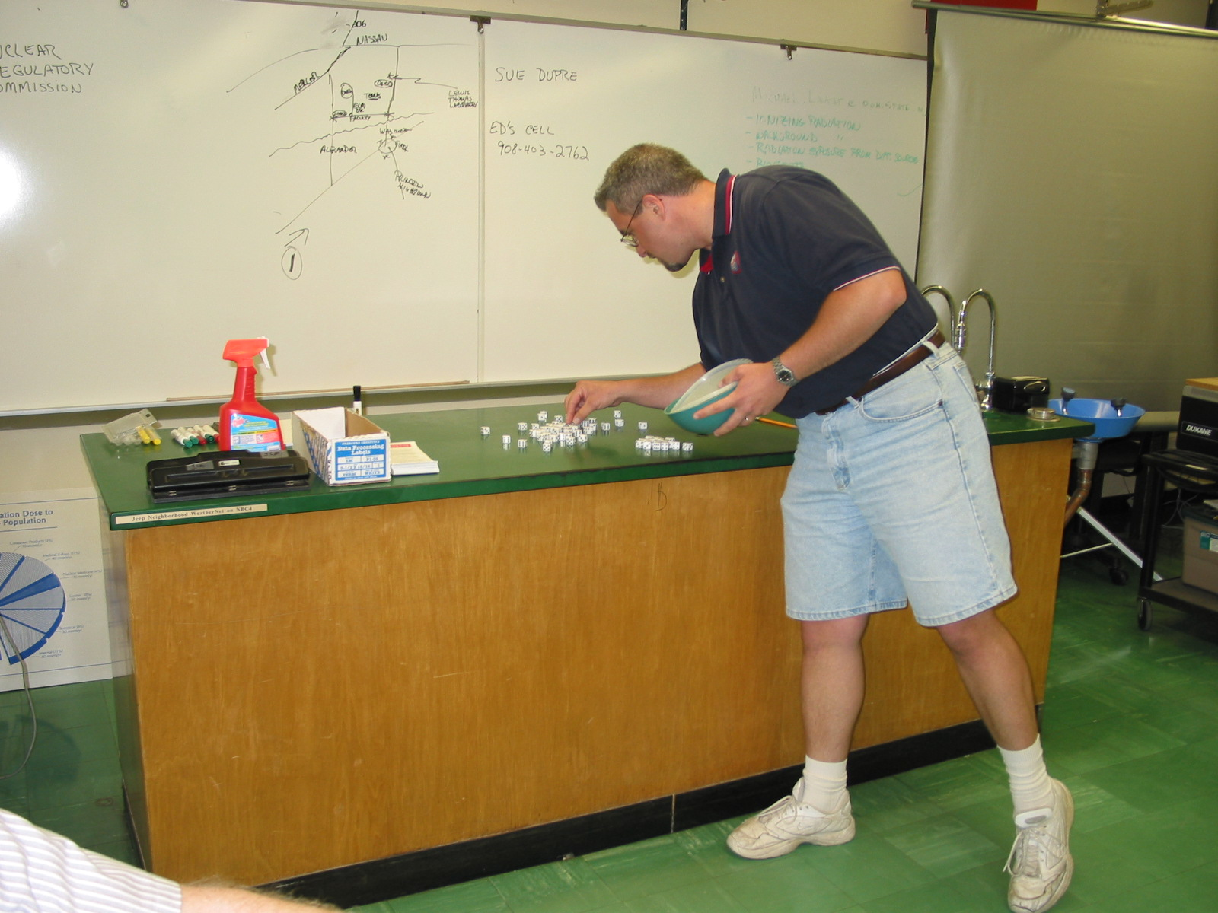
Lesson Title: Observing Rates of Radioactive Decay

By: Richard M. Stec
Pond Road Middle School
150 Pond Road
Robbinsville, NJ 08691
609-371-1140

Objectives:
- Students will be able to gather and organize data.
- Students will be able to graph simple data using Microsoft Excel.
- Students will be able to track the rate of decay of a radioactive element into its stable half-life element.
- Students will be able to explain that the point where the quantity of radioactive element becomes one half as much as there had been occurs at regular intervals.

Materials for each group of four students:
- 30 pairs of dice.
- One container large enough to hold the dice.
- One computer per group programmed with Microsoft Excel.

Procedure:
Each group will roll the 60 dice all at once. At the end of the die roll, all dice that turn up as either a 5 or a 6 will be removed. Count the dice that remain and record this number on the Microsoft Excel spread sheet that you have created. Put the remaining dice back into the container and roll them again. Repeat this procedure until there is only 1 die left or the group has completed ten rolls of the dice recording the result of each roll. Then graph the number of rolls versus the number of dice left after each roll using Microsoft Excel.
Observe that each group is completing the exercise properly. Offer advice as needed to ensure accurate results and learning. Have students answer the questions in the last section of the student sheet.
Students should observe that after each roll of the dice, about half of the dice are removed. This portion and the accompanying graphing activity should illustrate what half-life means.

Evaluation: The data sheet, accompanying graph of the results and answered questions count as a class-work grade.

References:
1. Alan L. Tobecken
15310 Harper
Dolton, Il 60419
708-849-1708

- Henry Clay Elementary School
13231 Burley
Chicago, Il 60633
312-535-5600

- Merrill Physics – Teacher Guide.

- http://www.iit.edu/~smile/ph9495.html

OBSERVING RATES OF RADIOACTIVE DECAY
NAME: ________________________ DATE: ___________ PERIOD: ____

Directions:
Gather the necessary materials and follow the procedure below.

Materials for each group of four students:
- 30 pairs of dice.
- One container large enough to hold the dice.
- One computer per group programmed with Microsoft Excel.

Procedure:
- Each group will roll the 60 dice all at once.
- At the end of the die roll, all dice that turn up as either a 5 or a 6 will be removed.
- Count the dice that remain and record this number on the Microsoft Excel spread sheet that you have created.
- Put the remaining dice back into the container and roll them again.
- Repeat this procedure until there is only 1 die left or the group has completed ten rolls of the dice recording the result of each roll.
- Then graph the number of rolls versus the number of dice left after each roll using Microsoft Excel.
- Using your textbook, answer the following questions in the space provided and staple this sheet to the spread sheet and graph you made during this activity. HAND IN!!

Questions:
- Define half-life in your own words. ________________________________________________________________________________________________________________

- Explain how the half-life of C-14 is used to date Native American or Roman artifacts? ________________________________________________________________________________________________________________

- Why can’t we use C-14 to date fossil remains from the Cretaceous Period? ________________________________________________________________________________________________________________

