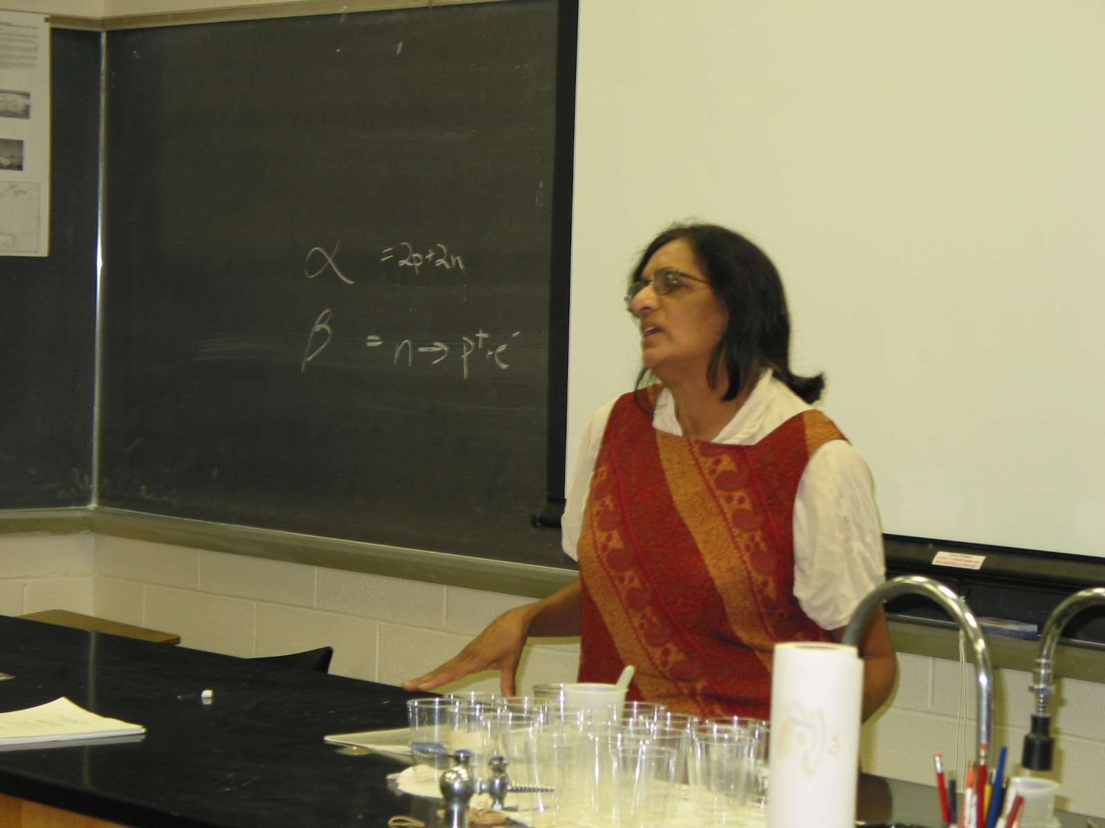

Instructor: Rekna Trivedi
School District: Roselle, NJ
Lesson Title: Radioactive Dating Model
Grade: 9
Subjects: General Biology, Physical Science
Objective:
- Students will be able to understand half-life of a radioactive substance.
- Students will be able to calculate the age of a fossil and read graphs.
Standards: NJ: 5.4-6 and 5.10-11

Pre-lab Discussion:
- Discuss about radioactive isotopes with examples.
- Methods used to determine age of fossils: a) relative dating, b) radiometric dating, which is more precise and reliable.
- Vocabulary: decay of material, half-life of a radioactive element
- Discuss the different kinds of decay mechanisms, the know rate of decay, and how an isotope changes to a different element after decay.

By finding out how much of a certain radioactive element in a rock has changes into the different corresponding element, scientists can determine the age of the rock. The ages of fossils can be determined according to the ages of the rocks where they were found.

Students were given the lab activity. They will:
- Explain the given graph (time in years)
- Determine the age of fossils (in years) = half life of the given radioactive element times the number of half lives undergone to reach the isotope content in a given problem.
- Follow direction and answer all questions.

Evaluation: quiz

LAB:

A Radioactive Dating Model

Lab Preview:
- What is a fossil? ___
- Why do scientists study fossils? ___
Problem:
How can a radioactive element be used to determine a fossil’s age?

Materials:
- 100 pennies
- cardboard box with lid
- graph paper
- pencil

Procedure:
- A rock or fossil may be dated by measuring the relative amount of a stable element with its radioactive parent element. As the rock ages, the amount of radioactive element becomes less and the amount of stable element increases. Examine the graph to see the decrease of a radioactive element over time.
- Place 100 pennies face up in the cardboard box and replace the lid.
- Shake the coins in the box for 10 seconds.
- Take off the lid and take out all coins that are face down.
- In the table, record the number of coins that you take out.
- Repeat steps 3 through 5 until all coins have been removed.

Data and Observations
Trial # | 0 | 1 | 2 | 3 | 4 | 5 | 6 | 7 | 8
Coins left
# removed

Questions:

- What happens to the number of coins remaining after each trial?

- Construct a graph of your results. Plot the number of coins remaining face up on the y-axis, and plot the trials on the x-axis. How does your graph compare with the graph shown?

- How does shaking the box represent the energy given off by the radioactive elements when they become stable?

- How is this model similar to the decay of a radioactive element?

- How is this model unlike the decay of a radioactive element?

- Why do you think radioactive dating is considered more accurate than dates calculated from fossil beds?

- Why are different radioactive elements used to date rock and fossils?

Critical Thinking:

Does radioactive dating with isotopes of uranium and thorium provide an estimate of the beginning, middle, or end of the periods of Earth’s formation? Explain your answer.

Structures and Functions:

Use the figure to answer the following question. The graph below represents the radioactive decay of an isotope. If the half life of thorium-230 is 75,000 years, how old is a fossil that contains only 1/16th of its original thorium-230? Provide calculations.

LAB: ANSWERS

A Radioactive Dating Model

Lab Preview:
- What is a fossil? Any remains of life from an earlier time.
- Why do scientists study fossils? To learn about the past
Problem:
How can a radioactive element be used to determine a fossil’s age?

Materials:
- 100 pennies
- cardboard box with lid
- graph paper
- pencil

Procedure:
- A rock or fossil may be dated by measuring the relative amount of a stable element with its radioactive parent element. As the rock ages, the amount of radioactive element becomes less and the amount of stable element increases. Examine the graph to see the decrease of a radioactive element over time.
- Place 100 pennies face up in the cardboard box and replace the lid.
- Shake the coins in the box for 10 seconds.
- Take off the lid and take out all coins that are face down.
- In the table, record the number of coins that you take out.
- Repeat steps 3 through 5 until all coins have been removed.

Data and Observations
Trial # | 0 | 1 | 2 | 3 | 4 | 5 | 6 | 7 | 8
Coins left | 100 | 57 | 30 | 18 | 12 | 7 | 5 | 2 | 1
# removed | 0 | 43 | 27 | 12 | 6 | 5 | 2 | 3 | 1

Questions:

- What happens to the number of coins remaining after each trial?
The number decreases by about half

- Construct a graph of your results. Plot the number of coins remaining face up on the y-axis, and plot the trials on the x-axis. How does your graph compare with the graph shown?
This will be a graph similar to the one showing half-life in this activity.

- How does shaking the box represent the energy given off by the radioactive elements when they become stable?
Shaking the box requires energy given off when the elements change to become stable.

- How is this model similar to the decay of a radioactive element?
After a given period of time, about half the coins have changed because of the energy.

- How is this model unlike the decay of a radioactive element?
The time for a given amount of a radioactive element to change to a stable element is exactly the same each time.

- Why do you think radioactive dating is considered more accurate than dates calculated from fossil beds?
Radioactive dating is more accurate because the rate of decay is exact. Fossil beds may be formed at different rates in different time periods.

- Why are different radioactive elements used to date rock and fossils?
Not all the rocks contain the same radioactive elements. Also, not all radioactive elements have a decay rate that can be used with every age rock.

Critical Thinking:

Does radioactive dating with isotopes of uranium and thorium provide an estimate of the beginning, middle, or end of the periods of Earth’s formation? Explain your answer.
No. This method estimates the age of the oldest unmelted surface rocks on earth. Since the surface of earth probably melted many times as the planet formed, the earth should be older than these rocks.

Structures and Functions:

Use the figure to answer the following question. The graph below represents the radioactive decay of an isotope. If the half life of thorium-230 is 75,000 years, how old is a fossil that contains only 1/16th of its original thorium-230? Provide calculations.
An isotope content of 1/16 will occur after four half-lives.
# of half lives x Half life of element = # of years old.
4 x 75,000 years = 300,000 years

