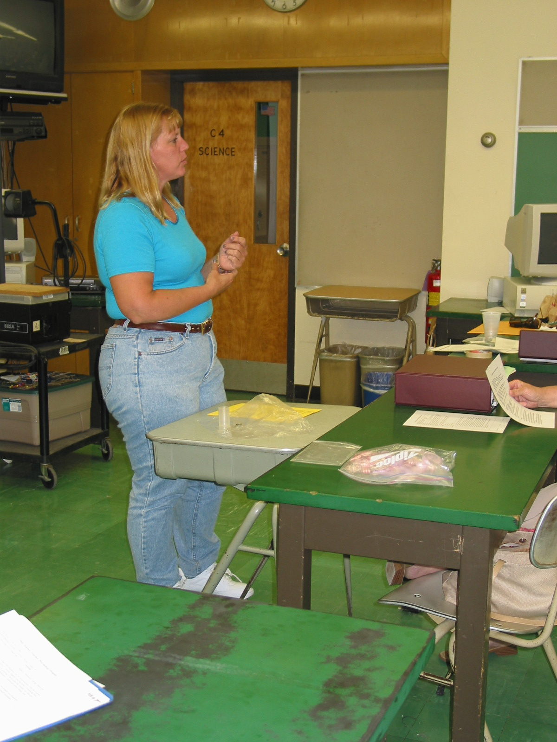

Instructor: Patty Vingara (2002 Science Teacher Workshop participant)
School District: Hamilton Twp., NJ
Lesson Title: Radon Detection Devices and the Comparison of Samples
Grades: 9-12
Subject: Chemistry
Overview: After obtaining basic background information on 3 types of radon detectors, students will build and compare readings from an alpha track radon detector.

Objectives:
1) The students will gain knowledge of three basic types of radon detection devices (Charcoal canister and liquid scintillation, alpha track, and electret ion detectors) and how each works.
2) Students will construct an alpha track detector and process the results according to the directions given.
3) The students will read and record the radon concentrations using a microscope.
4) The student will compare and contrast the concentration amounts to see if patterns result in the data.

Materials and Resources:
Information for this lab, background, equipment and procedure are taken from
- Tocci, Salvatore and Veihland, Claudia, Chemistry. Holt, Rinehart and
Winston. Austin, Texas. 1989. Pages 786-789.
- “CR-39 Monomer” http://corporate.ppg.com/ppg/corporate/default.htm
- EPA resources: http://www.epa.gov/region01/students/teacher/aire.html
- Alpha Trak, 141 Northridge Drive, Centralia, WA 98531, (360-736-3884) as a source for the CR-39 and other supplies

Background:
Charcoal canister and liquid scintillation detectors contain activated charcoal. The amount of decay products absorbed into the charcoal is measured to determine the radon concentrations.
Alpha track detectors use a plastic sheet (often used in the production of prescription eyewear) that is exposed to alpha particles. As these particles strike the plastic, they leave tracks. After chemical treatment, the tracks become visible and can be counted to determine the radon concentration.
Electret ion detectors contain electrostatically charged Teflon disks. Ions generated by radon decay strike the disk and reduce the voltage of the disk. This reduction is measured and the corresponding radon concentration is calculated.

Material:
- CR-39 plastic (with polyethylene film on both sides)
- 2 Index cards
- Metric ruler
- 2 Etch clamps
- Microscope
- 2 Paper clips
- Push pin
- Scissors
- 2 Plastic cups and lids
- Tape
- Tissue paper
- Test tubes
- Beaker
- Heat source
- NaOH

Procedure:

PART I
- Cut 2 2 cm by 4 cm rectangles from the index cards
- Peel the polyethylene film off the CR-39 that has marked lines on it.
- Use the pushpin to create an identification mark (follow teacher directions for the labels) on this side.
- Use a loop of tape to attach the other side to the index card.
- Place the CR-39 in the cup with the plastic on the top.
- Label the cup with the same label given to the plastic (example group A basement) Make sure to complete these steps for each detector.
- Cut a hole in each lid and cover them with tissue paper. This will keep out dust.
- Place the lids on the corresponding cups.
- Suggested placement for the cups is the basement and the highest level of the home, an attic or upper floor.
- Leave these in place for 3-4 weeks.

PART II
- Return the cups after the allotted time.
- This should be done as a teacher demonstration.
- Dissolve 250g of NaOH in enough water to make 1.00 liter. (Dissolve small portions slowly to avoid excess heat.
- With students well away from the demonstration area and wearing the proper protective gear, add enough NaOH in test tubes to immerse the plastic.
- Have students attach the CR-39 to the etching clamp. Then unfolding a paper clip to create an “s” shape to hook onto the etching clamp. Make sure this is done for each sample.
- The teacher should then place the hooked sample into the test tubes and the tubes into a water bath (beaker filled with water).
- Heat the water to boiling for 30 minutes
- After time is up, remove the CR-39 and gently dry it with a soft tissue

PART III
- With the microscope on 10X magnification, measure the field of vision to calculate the area of the field (Look through the microscope at the ruler. This is the diameter. ) Area πR²
- Place the CR-39 on the microscope stage and focus on the topside of the plastic.
- Count the number of tracks etched in the plastic. These can be recorded in the number of tracks per cm². (If the numbers of tracks are too numerous, the field can be divide into sections and then several sections can be averaged to get a more accurate concentration.)
- Repeat this with the second sample.
- Students should record each sample, the number of tracks counted, the size of the viewed area and then calculate the concentration of tracks. Then divide these numbers by the number of days the sample was exposed to find the number of tracks per cm² per day.
- Student may then use the class data to compare samples and suggest reasons for differences between lower house level readings and upper level house readings. They may also wish to compare samples from one house to the other by age, location or quality of house insulation. They may also wish to compare results according to the house building materials.

