STATE OF NEW JERSEY
BUREAU OF SECURITIES
P.O. Box 47029
Newark, New Jersey 07101
(973) 504‑3600

IN THE MATTER OF:  Cresttrademining Limited,  Respondent. | SUMMARY CEASE  AND DESIST ORDER

Pursuant to the authority granted to Amy Kopleton, Acting Chief of the New Jersey Bureau of Securities (“Bureau Chief”), under the Uniform Securities Law (1997), N.J.S.A. 49:3-47 to -89 (“Securities Law”) and certain regulations thereunder, and based upon documents and information obtained during the investigation by the New Jersey Bureau of Securities (“Bureau”), the Bureau Chief hereby finds that there is good cause and it is in the public interest to enter this Summary Cease and Desist Order (“Order”) against Cresttrademining Limited (“Cresttrademining”).
The Bureau Chief makes the following findings of fact and conclusions of law:
FINDINGS OF FACT
- The Respondent
- Cresttrademining conducts its business on the internet, principally by means of a website accessible at https://www.cresttrademining.com (the “Cresttrademining Website”). Cresttrademining holds itself out as a cryptocurrency and forex trading firm.
- Cresttrademining purports to be located at “3238 Doctors Drive, Los Angeles, California, 90017 USA.” This address is the same address of other cryptocurrency websites, such as RealBitcoreMining, which was the subject of a Summary Cease and Desist Order by the Bureau on October 27, 2021.
- Cresttrademining claims to be “a legal company registered in the United Kingdom.” The Cresttrademining Website provides an image of a purported Certificate of Incorporation of a Private Limited Company issued to Crestrademining by the Registrar of Companies for England and Wales. Additionally, Cresttrademining claims to be registered in the United Kingdom as “BIT KINDLE LIMITED” with a separate registration number than listed on the purported Certificate of Incorporation.
- However, a search of Cresttrademining on the United Kingdom business registry, Companies House, yields no results. Moreover, a search of the United Kingdom business registry using the company number listed on the Certificate of Incorporation yields results for another entity, for Nexus Trade Ltd, an entity that dissolved on July 6, 2021. A search for BIT KINDLE LIMITED on the United Kingdom business registry reveals that this entity dissolved on October 27, 2020.
- Additionally, on its homepage, the Cresttrademining Website lists a third purported identification number. A search of the United Kingdom business registry using this company number yields results for a different entity, Geotech Interservis L.P.
- Cresttrademining is not and has never been registered in any capacity with the Bureau.

- Cresttrademining is Acting as an Unregistered Broker-Dealer
- Cresttrademining describes itself as a cryptocurrency and forex trading platform equipped with “proven strategies and advance audit technology, [whose] experts can able [sic] to draw the assured resolutions on the grounds of variations in the field.” Moreover, Cresttrademining claims on its website that it “is the best way to make your business portfolio mature faster,” and its “investment platform is offering profitable financing opportunities to everyone who endeavours.”
- Cresttrademining claims that its “goal is not to conduct the tough competition, but to receive a stable profit on the crypto-currency market using our own strategy. [It has] developed special investment packages with optimum service plans and affiliate program for passive income for investors.” Cresstrademining also states that “the company's income is generated by successfully executed trades on the currency market” and “guarantees you the stable and secured risk free income at best of your selected investment package.”
- The Crestttrademining Website describes the Cresttrademining’s Affiliate Program that provides a 5% Referral Commission for all members and does not require any investment. Cresstrademining states that it “developed a single-level affiliate program according to which a program beneficiary will be charged with 5% of commission charge from the each of his/her partner deposit amounts.” Cresttrademining also states that one “can gain a passive income with no direct investments.”
- Cresttrademining is not and has not been registered with the Bureau as a broker-dealer.

- Cresttrademining’s Securities
- The Cresttrademining Website is accessible to the general public, including residents of New Jersey.
- Cresttrademining offers three different investment “solutions” (collectively, the “Cresttrademining Investment Plans”) – albeit with practically no specific information. The Cresttrademining Investment Plans range from a $100 to $999 “solution” to a $10,000 to $20,000 “solution” in price. Cresttrademining publishes the following graphics on the Cresttrademining Website to demonstrate its “20%”, “40%”, and “90%” investment solutions (collectively the “Cresttrademining Securities”), respectively:
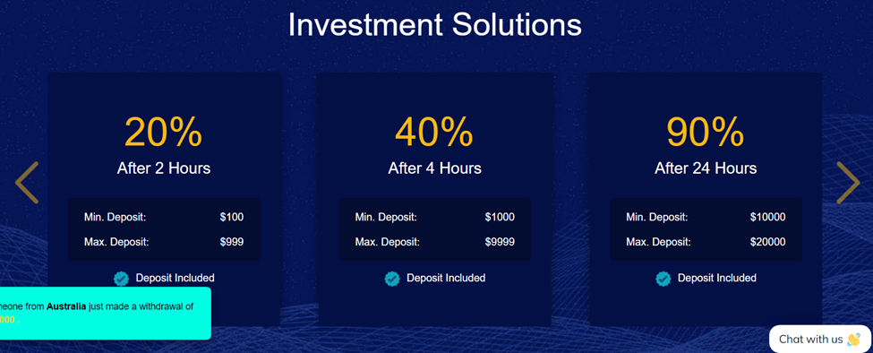
- A section on the home page of the Cresttrademining Website states: “Cresttrademining guarantees you the stable and secured risk free income at best of your selected investment package.”
- On the bottom left portion of the Cresttrademining Website, boxes containing withdrawal information from purported “investors”, such as:
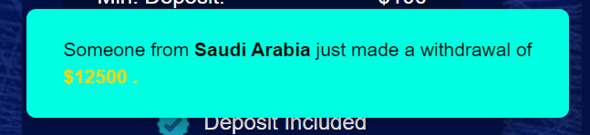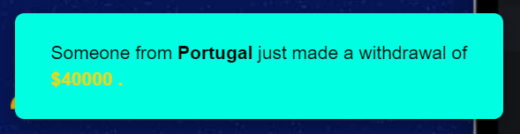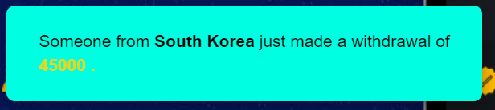
- Cresttrademining and the Cresttrademining Website do not notify potential investors of the risks associated with cryptocurrency trading and markets, and any risk of investing with Cresttrademining itself. Instead, the Cresttrademining Website uses purported withdrawal information and other illustrations to imply that its clients are receiving risk-free investment returns.
- Except for the name of a single director, the Cresttrademining Website does not provide any information regarding the identity of Cresttrademining Website officers, directors, or management team. It does not indicate what credentials, qualifications or experience these individuals may have.
- Cresttrademining and the Cresttrademining Website do not disclose to potential investors the risks associated with its plans, Forex trading, cryptocurrency trading, or any of the risks of the Cresttrademining Securities. Moreover, the Cresttrademining Website states “the risks for our investors are minimized due to the professional team and our experience. Each company's investor will receive a daily profit according to the terms of the investment plan that was chosen.”
- The Cresttrademining Securities are securities as defined by N.J.S.A. 49:3-49(m).
- Cresttrademining offers the Cresttrademining Securities to the general public, including New Jersey residents.
- The Cresttrademining Securities are neither registered with the Bureau, nor “federally covered,” nor exempt from registration, as required by the Securities Law.
- New Jersey Investor
- At least one New Jersey resident invested with Cresttrademining (the “New Jersey Investor”).
- In or about March 2022, the New Jersey Investor learned of Cresttrademining through the Instagram page of a purported friend, who referred the New Jersey Investor to another Instagram user, “Coach Linda” @linda_haynes_fx_mentor, who helped the New Jersey Investor open “a trading account on her company broker website,” the Cresttrademining Website.
- In or about March 2022, the New Jersey Investor sent $530 through Zelle to an email address provided by “Coach Linda.” This investment was then reflected in the New Jersey Investor’s Cresttrademining account. Soon after making the deposit, a Cresttrademining representative advised the New Jersey Investor that her Cresttrademining account had a profit of $10,678.
- Upon requesting a withdrawal, a Cresttrademining representative informed the New Jersey Investor that she needed to pay withdrawal fee charges of $2,950 before she could make a withdrawal. After paying this fee, the representative informed the New Jersey Investor that she needed to pay an additional $7,850 for a token code to make the withdrawal. The representative directed the New Jersey Investor to contact her account representative for further information.
- The New Jersey Investor contacted “Coach Linda” who confirmed that she needed to pay $7,850 to get the pin to withdraw the profit and advised that this amount would be refunded and would be the last fee. “Coach Linda” instructed the New Jersey Investor to go to a local Bitcoin ATM and deposit $8,000 due to Bitcoin charges.
- On or about March 12, 2022, the New Jersey Investor received a message from Vertexglobal Trade stating she needed to pay a “reflection fee” of $16,450 before the withdrawn amount could be reflected in the New Jersey Investor’s bank account.
- On or about March 13, 2022, the New Jersey Investor contacted Cresttrademining and requested a waiver of the reflection fee or a refund of the $11,500 previously deposited.
- The New Jersey Investor did not pay the “reflection fee” and has not yet received any principal or profits back from Cresttrademining.
- Omissions of Material Facts to Potential Investors by Cresttrademining in the Offer of the Cresttrademining Securities
- In connection with the offer of securities Cresttrademining omits the following material facts:
- The identity of its principals and management;
- The company’s financial statements, including its assets, liabilities, and profitability;
- The risks of investing in Cresttrademining Securities;
- Additional fees that will be charged for the withdrawal of funds;
- Information about the payment of taxes on any gains or losses incurred; and
- That the Cresttrademining Securities are not registered with the Bureau as required by the Securities Law.
- Untrue Statements of Material Facts and Omissions of Material Facts in Connection With the Offer of the Cresttrademining Securities
    - Legal Company in United Kingdom

- The Cresttrademining Website claims “we are a legal company registered in the United Kingdom.” However, it is in fact not registered in the United Kingdom.
ii. Deposit and Withdrawal Fees
- The Cresttrademining Website states that “we don’t have any hidden fees” for money deposit/withdrawal. However, at the time of withdrawal, Cresttrade Mining informed the New Jersey Investor of a previously undisclosed withdrawal fee, a pin code fee, and a reflection fee.
CONCLUSIONS OF LAW
- The Cresttrademining Securities are “securities” as defined by N.J.S.A. 49:3-49(m).
- Cresttrademining is offering securities that are neither registered with the Bureau, nor “federally covered,” nor exempt from registration, in violation of N.J.S.A. 49:3-60.
- Cresttrademining is effecting or attempting to effect transactions in securities for the accounts of others or for its own account without registration as a broker-dealer in violation of N.J.S.A. 49:3-56.
- In connection with the offer of the Cresttrademining Securities, Cresttrademining is making untrue statement of a material fact and omitting to state material facts necessary in order to make the statements made in light of the circumstances under which they were made, not misleading to investors, in violation of N.J.S.A. 49:3-52(b).
- N.J.S.A. 49:3-67 empowers the Bureau Chief to issue orders that are reasonably necessary to carry out the provisions of the Law.
- N.J.S.A. 49:3-69(a)(1) empowers the Bureau Chief to issue a cease and desist order against persons engaged in prohibited activities, directing them to cease and desist from further illegal activity or doing acts in furtherance thereof.
- Cresttrademining’s violations are continuous and ongoing, therefore making a cease and desist order in the public interest and an appropriate remedy.
ORDER
THEREFORE, it is on this______ of ______2022, ORDERED that:
- Cresttrademining and any person, employee, officer, director, entity, agent, Cresttrademining representative, or independent contractor under Cresttrademining direction or control immediately CEASE AND DESIST from:
- offering for sale any security in New Jersey until the security is registered with the Bureau, is offered for sale pursuant to an exemption from registration under the Securities Law, or is a federally covered security;
- acting as broker-dealers or agents in New Jersey until each is registered with the Bureau or are acting pursuant to an exemption from registration under the Securities Law;
- making material misstatements of fact, or omitting to state material facts necessary in order to make the statements made, in light of the circumstances under which they are made, not misleading in connection with its offer and/or sale of securities in New Jersey; and
- violating any other provisions of the Securities Law and any rules promulgated thereunder for the sale of any security in New Jersey.
- All exemptions contained in N.J.S.A. 49:3-50 subsection (a) paragraph 9, 10, and 11 and subsection (b) are hereby DENIED as to Cresttrademining.
- All exemptions to the registration requirements provided by N.J.S.A. 49:3-56(b), N.J.S.A. 49:3-56(c) and N.J.S.A. 49:3-56(g) are hereby DENIED as to Cresttrademining.
________________________________
Amy Kopleton
Acting Chief, New Jersey Bureau of Securities

NOTICE OF RIGHT TO HEARING
Pursuant to N.J.S.A. 49:3-69(a)(1)(i) the Bureau Chief shall entertain on no less than three days’ notice a written application to lift the Order to Cease and Desist on written application of the person subject thereto and in connection therewith may, but need not, hold a hearing and hear testimony, but shall provide to the person subject thereto a written statement of the reasons for the Order to Cease and Desist.
Pursuant to N.J.S.A. 49:3-69(a)(l)(ii), upon service of notice of the Order to Cease and Desist issued by the Bureau Chief, the person subject thereto shall have up to fifteen (15) days to respond to the Bureau in the form of a written answer and written request for a hearing. The Bureau Chief shall, within five days of receiving the answer and request for a hearing, either transmit the matter to the Office of Administrative Law for a hearing or schedule a hearing at the Bureau of Securities.
Orders issued pursuant to N.J.S.A. 49:3-69 shall be subject to an application to vacate upon 10 days’ notice, and a preliminary hearing on the Order shall be held in any event within twenty (20) days after it is requested, and the filing of a motion to vacate the Order shall toll the time for filing an answer and written request for a hearing.
Pursuant to N.J.S.A. 49:3-69(a)(l)(iii), if any person subject to the Order fails to respond by filing a written answer and written request for a hearing with the Bureau or moving to vacate the order within the fifteen (15) day prescribed period, that person shall have waived the opportunity to be heard. The Order will be a Final Order and shall remain in effect until modified or vacated.

NOTICE OF OTHER ENFORCEMENT REMEDIES
You are advised that the Uniform Securities Law provides several enforcement remedies, which are available to be exercised by the Bureau Chief, either alone or in combination. These remedies include, in addition to this action, the right to seek and obtain injunctive and ancillary relief in a civil enforcement action, N.J.S.A. 49:3-69, and the right to seek and obtain civil penalties in an administrative or civil action, N.J.S.A. 49:3-70.1.
You are further advised that the entry of the relief requested does not preclude the Bureau Chief from seeking and obtaining other enforcement remedies against you in connection with the claims made against you in this action.

