November 27, 2024

Honorable Tahesha Way
Lt. Governor
Department of State
PO Box 300
Trenton, New Jersey 08625

RE: Notice of Meeting of the State Planning Commission

Dear Secretary Way:

A meeting of the New Jersey State Planning Commission is scheduled for Wednesday, December 4, 2024 at 10:00 a.m. This meeting will serve as the Commission’s reorganization meeting.

The meeting will be held at as a Zoom virtual meeting:
https://us02web.zoom.us/j/81243828648?pwd=dnFHcmw4azZCUm5LcWhtdjMvcFRQdz09

Enclosed is the agenda to the extent known at this time.

This notice is sent to you pursuant to the Open Public Meetings Act, N.J.S.A. 10:4-6 et. seq.

Sincerely,

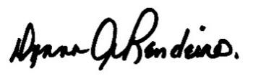

Donna Rendeiro
Executive Director
Office of Planning Advocacy

DR:sb
cc: Asbury Park Press
Atlantic City Press
Bergen Record
South Jersey Times
The Star-Ledger
Ingrid Hernquist, Legislative Librarian

