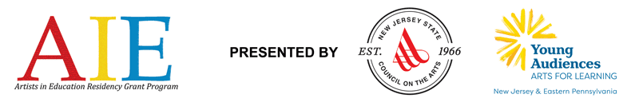
New Jersey State Council on the Arts in partnership with
Young Audiences Arts for Learning New Jersey & Eastern Pennsylvania

ARTISTS IN EDUCATION
RESIDENCY GRANT PROGRAM
APPLICATION AND INSTRUCTIONS
For residencies to take place September 2020 – June 2021

Application Deadline: Friday, February 7, 2020

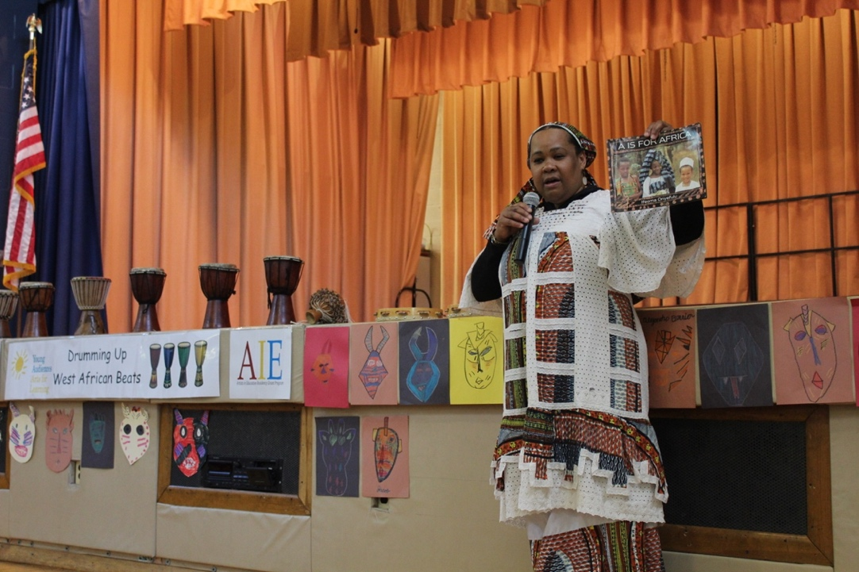
Above: Candace Hundley-Kamate of The Seventh Principle begins the Culminating Event at Charles Olbon School. The elementary school hosted a West African song and dance residency in 2018-2019.

The Artists in Education Residency Grant Program is a co-sponsored project of the New Jersey State Council on the Arts and Young Audiences Arts for Learning New Jersey & Eastern Pennsylvania. The program is carried out in partnership with regional partners, including Appel Farm Arts & Music Campus, Count Basie Center for the Arts, and Morris Arts.
APPLICATION INSTRUCTIONS
Please review the Grant Application Guidelines carefully before getting started. If you are in need of special accommodation in filing this AIE Grant Application, please contact us at 609.984.7019. This application is available online at www.njaie.org, www.yanjep.org, and www.artscouncil.nj.gov.

Handwritten, incomplete, or faxed applications will not be accepted.

If you would like to request an extension, requests must be received via e-mail (sclarke@yanjep.org) no later than Friday, January 17, 2020. There will be only one extension request permitted per school. Note: A request does not guarantee an extension will be permitted. Applicants are advised to mail applications early.

All applications must be submitted or postmarked by Friday, February 7, 2020 to be considered.

Please complete the application, filling out the following sections completely:
- Applicant Information
- Certification with Signatures
- Residency Grant Narrative
- Budget
- Budget Narrative
- Two (2) Letters of Support
  - One must be from a school administrator

Special Instructions for Reapplying Schools

- Please confer with your AIE Partner when developing a new application.
- You should also request an AIE Partner Letter of Consideration, as well as one from your most recent AIE Resident Artist, to include in your application packet.
- If you plan to work with the same AIE Resident Artist for the proposed residency, please include them in the planning and application process.

There are three (3) ways to submit your completed application:
- Submit via the online application at www.njaie.org
- E-mail a completed Word doc to sclarke@yanjep.org
  - Please save your document as SchoolName-AIE-FY21.doc
  - Please have the subject line read: Your School Name – AIE FY21 Application
- Mail a completed, typewritten document to:

US Postal Service  Samantha Clarke, AIE Administrator  c/o New Jersey State Council on the Arts  PO Box 306  Trenton, NJ 08625 | UPS, FedEx, etc.  Samantha Clarke, AIE Administrator  c/o New Jersey State Council on the Arts  33 West State Street, 4th Floor  Trenton, NJ 08608

AIE RESIDENCY GRANT APPLICATION

PLEASE READ THE AIE PROGRAM GUIDELINES BEFORE COMPLETING THESE FORMS. If you are selecting a mural arts or visual arts residency that results in a permanent structure or installation, please see the Mural Arts Addendum at www.njaie.org.

Residencies must be a minimum of twenty (20) days and be part of the regular school day. A residency day is considered to serve approximately four (4), consecutive, 45-minute class periods. The core group of students should meet with the Resident Teaching Artist during every workshop day. Proposals for less than the minimum residency length will not be considered.

First-Time and Reapplying Applicants: You must submit at least two (2) letters of support with this application. One must come from a school administrator who will be involved in the residency.

First-Time Applicants: If you have a pre-existing relationship with an AIE Resident Teaching Artist that you intend to work with in your AIE-funded residency, please be sure to include the artist on your Steering Committee. If you have not been working with an AIE-approved artist, you and your AIE Partner will select an AIE artist through interviews after receiving notice of a grant award.

Previous AIE Grantee Recipients: If you are continuing to work with an AIE-approved artist from a prior AIE residency, please be sure to include the artist on your Steering Committee. Previous and current AIE grantees must include Letters of Consideration from their AIE Partner, as well as from the AIE Resident Teaching Artist with whom they worked most recently. Please include documentation of past residencies (e.g. newspaper articles, press releases, blogs, student work, photographs, etc). Please send no more than five (5) pages of supporting materials with your application.

APPLICANT INFORMATION

Has your school previously received AIE grants? Yes No
If yes, list year(s) grants awarded:
Proposed target grade(s):
Proposed total number of students who will meet with the Resident Teaching Artist every residency day (core group):
Proposed total number of students participating in residency project activities (This is both the participating group and the core group):
Proposed total number of adults impacted by the project activities (teachers, parents, etc.). These are adults who participate in daily residency activities and/or professional development, those attending Culminating Event, etc.:
Is this a proposal for a new project or for continued work on an existing project?
Please provide a fifty (50) word summary of your grant proposal, including the art form, students and grade levels to be served, and primary residency goals:

Name of School:
Superintendent/CEO:
Federal ID Number:
School District:
School Street Address:
City:
State:
Zip Code:
County:

Certification: By signing below, I certify that I have read and support the residency proposal.
Principal’s Name | Principal’s Telephone | E-mail (provide one address only)
Authorizing Official’s Signature |  |  | Date (mm/dd/yyyy)
Legislative District: State Federal
(This information is available at http://www.njleg.state.nj.us/members/legsearch.asp and http://www.house.gov/representatives/find/.)
APPLICANT STATUS  Which category best describes your organization’s  legal status? Please place an X next to appropriate selection. |  | APPLICANT INSTITUTION  Which category best describes your organization?  Please place an X next to appropriate selection.
Nonprofit Organization  State Government  Regional Government | County Government  Municipal Government  None of the Above | School District  Elementary School  Middle School | Secondary School  Vocational/Technical School  School/Other:

DISCIPLINE
Choose the one discipline which best describes the desired residency or project.

Enter the appropriate code numbers and letter prefix (if applicable) for which you are applying here:

(01) Dance | (03) Opera/Music Theatre | (07) Crafts | (10) Literature
A. Ballet  B. Hip Hop  C. Folk-inspired  D. Jazz  E. Modern  (02) Music  A. Band (does not include jazz or popular)  B. Chamber (includes only one musician/part)  C. Choral  D. New (includes experimental & electronic)  E. Folk-inspired  F. Jazz  G. Popular (includes rock)  H. Solo/Recital  I. Orchestral (includes symphonic, chamber orchestra) | A. Opera  B. Musical Theatre  (04) Theatre  A. Theatre (includes classical, contemporary, experimental)  B. Mime  C. Puppetry  D. Theatre for young audiences  E. Storytelling  (05) Visual Arts  A. Experimental (includes conceptual, installations, new media, new approaches)  B. Graphic (includes printmaking, book arts, drawing, does not include graphic design)  D. Painting (includes oil, acrylic, watercolor)  F. Sculpture  (06) Design Arts  A. Architecture  B. Fashion  C. Graphic/Illustration  D. Industrial  E. Interior  F. Landscape Architecture  G. Urban Design/Planning | A. Clay  B. Fiber  C. Glass  D. Leather  E. Metal  F. Paper  G. Plastic  H. Wood  I. Mixed Media  (08) Photography  (09) Media Art  A. Film  B. Audio (includes radio, sound)  C. Video  D. Technology, Experimental | A. Fiction  B. Nonfiction  C. Playwriting  D. Poetry  (11) Interdisciplinary*  Pertaining to art forms/art works that integrate more than one arts discipline to form a single work (e.g. collaboration between/among the performing and/or visual arts). Includes performance art.  (12) Folk/Traditional Arts*  Pertaining to oral, customary, material, and performance traditions informally learned and transmitted in contexts characteristic of cultural, religious, linguistic, occupational, and/or regional groups.  *Schools interested in applying for these residencies must first consult with AIE staff at 609-984-7019.

STEERING COMMITTEE/RESIDENCY SUPPORT STRUCTURE
Refer to the glossary in Guidelines definitions.

List the Grant Contact:
Please provide the contact person’s name, phone number, and e-mail address for questions regarding this grant proposal.
Name: Title/Position: Phone number: E-mail address:

List the members of the Steering Committee:
On-Site Coordinator: Title/Position: E-mail address:
Administrative Coordinator: Title/Position: E-mail address:
Teacher Liaison (if applicable): Title/Position: E-mail address:
Teaching Staff (Please include grade level and subject area or current title, specifying those who will have a direct role in the residency):
Community Members (Please include affiliations: i.e. parent, businessperson, Resident Teaching Artist, etc.):
How did you hear about the AIE Grant?
An AIE school From my administrator AIE Staff (please specify) Teaching Artist
Technical Assistance Workshop Direct mail E-mail Other (please specify)

AIE Orientation Meeting: Please choose one of the dates below that your On-Site Coordinator and Administrative Coordinator will participate in an AIE Orientation meeting with the AIE staff. Refer to the glossary in Guidelines for more details.

Thursday, July 23, 2020 at Young Audiences Arts for Learning NJ & Eastern PA (Princeton, NJ)

Thursday, August 13, 2020 at Young Audiences Arts for Learning NJ & Eastern PA (Princeton, NJ)

RESIDENCY GRANT NARRATIVE
Fields are set with word limits and will end when the limit is reached. As you type, the field will expand to accommodate your entry and push subsequent content down. This will automatically increase the amount of document pages that you will submit, and document length will vary for each user.

1. Please describe the proposed residency and how it will augment the existing arts curricula at your school. Why was this art form selected? (750-word limit)

2. What long-term impact does your school hope to achieve through this residency?

3. Please describe what students will learn from this residency. List no more than 5 student outcomes you anticipate from this residency. Please be succinct and realistic in your anticipated outcomes.

Students will

Students will
Students will
Students will
Students will

4. Please describe what teachers will learn from this residency. List no more than 3-5 teacher outcomes you anticipate from this residency. Please be succinct and realistic in your anticipated outcomes.

Teachers will
Teachers will
Teachers will
Teachers will
Teachers will

5. Describe the artistic processes that students and teachers will engage in to meet the outcomes stated in questions 3 and 4. (500-word limit)

6. Does your school/district have a strategic plan or set of adopted goals that includes the arts? If yes, please describe and highlight any ways that AIE might help your school achieve these goals.

7. Number of core groups: Number of students in each Core group: (This figure should match the figure listed on page 2.)

Briefly describe the criteria for selecting the core and participating groups. (500-word limit)

8. How do you plan to document and evaluate the outcomes of the student and teacher goals described in questions 3 and 4? (i.e.: photos, video, student journals, social media, etc.) (500-word limit)

9. Please provide the following demographic information:

 | # Courses | # Full-Time Staff | # Part-Time Staff | Comments
Creative Writing:
Dance:
Media Arts:
Music:
Theatre:
Visual Arts:
Other:

Site and Community

10. Briefly describe your school and community, including geographic and socio-economic characteristics.

11. Please describe any existing or planned partnerships with community or cultural organizations, highlighting those that may play a role in your proposed residency.

Support/Scheduling

12. Please describe how you anticipate scheduling student workshops (with focus on aligning scheduling for the core student groups). Be sure to provide the projected number of times per week, length of sessions, and the general time of year for the proposed residency. (See Guidelines for residency components and a sample timeline. Please remember that four (4) of the twenty (20) residency days include the Planning Meeting, professional development day, Culminating Event, and Reflection Day.)

13. Please describe how you anticipate scheduling planning meetings with your Steering Committee, AIE Resident Teaching Artist, and AIE Partner.

Support/Facility

14. Please describe the artist’s workspace in your school, with particular consideration for the specific needs of the artistic disciplines involved. Describe the facilities/equipment available for the artist’s use. (300-word limit)

Reapplying Grant Recipients Only

15. Is your school currently (2019-2020) participating in an AIE residency?
Yes No

16. If yes, in what stage is your residency (planning stage, residency has started, PD for teachers has taken place, etc.) and can you describe your experience thus far? (500-word limit)

17. If no, briefly summarize what took place in past AIE residencies, and describe if/how the proposed residency relates to past residencies. Reminder: Please provide no more than 5 pages of documentation from past residencies. (500-word limit)

18. Describe how previous and proposed residencies and professional development activities will help to create sustainability for the arts in your school. (500-word limit)

Proposed AIE Residency Grant Budget
School Match Item  The list below contains a variety of items schools have paid for to support their AIE residency. Please decide which items your school will need in order to meet the requirements of your proposed residency. School must fund either a visiting artist, assembly, or field trip. | Amount  The total amount matched by the school should be a minimum of $2,000*, which is 1/3 the amount AIE pays for the Resident Teaching Artist fees for a 20-day residency. | Income Source  Please list how the school will secure the funds needed (i.e.: fundraising, existing budget, in-kind donation, etc.).  In-kind donations should not comprise more than 50% of your match.
Teacher Release Time | $
Substitute Teacher Fees | $
Materials/Supplies | $
Equipment | $
Field trip | $
Visiting Artist(s)/Assembly Program | $
Artist Tools Rental Fee | $
Extra Residency Days  (Fee of $300 X ____days) | $
Extra Travel for Artist  ($0.535 per mile X roundtrip miles) | $
Administrative Costs | $
Documentation/Evaluation/Publicity | $
Other: | $
Other: | $
Other: | $
Total | $
*If your application proposes a mural art or permanent art installation, please see the Mural Arts Addendum on the AIE website (www.njaie.org). Those proposing a mural arts or permanent art installation are required to provide a $3,000 match for the residency. This match will fund additional residency days and travel for the artist and will be billed to the school at the start of the residency.

For budget-related questions, consult the definitions in the Guidelines or call AIE at 609.984.7019.
BUDGET NARRATIVE

Please provide a brief explanation of your school’s match, and how you arrived at the items you listed as necessary to support your residency.

End of 2020 – 2021 AIE Residency Grant Application

FINAL CHECKLIST
Please use this checklist to indicate the items submitted and ensure that your application packet includes all of the required materials. This document is for your records and does not need to be submitted with the application.
Only complete applications will be considered.
School Name:

APPLICATION CHECKLIST
I have read the AIE Guidelines.
I have read the Mural Arts Addendum (if applicable).
I have completed the Applicant Information section of the application.
I have completed the Certification section of the application.
I have completed the Residency Grant Narrative section of the application.
I have completed the Budget and Budget Narrative section of the application.
I have submitted two (2) Letters of Support, including one from a school administrator who will be involved in the residency.
I have no more than five (5) pages of documentation from past residencies (reapplying schools only).
I have a Letter of Consideration from my AIE Partner (reapply schools only).
I have a Letter of Consideration from my AIE Resident Teaching Artist (reapplying schools only).
All documents have been submitted via:
E-mail to sclarke@yanjep.org
Mail
Uploaded to the online AIE application (www.njaie.org)

Thank you for your application.
Please keep a copy for your records.
Awards will be announced in late May 2020.

