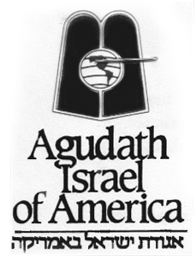

MEDIA OPPORTUNITY

WHAT: Agudath Israel of America announces the 12thSiyumHaShas (Talmud Completion Celebration) of Daf Yomi, to take place on Wednesday, August 1, 2012. This momentous occasion occurs only once every 7 ½ years, and marks the completion by tens of thousands of Jews worldwide of the “Daf Yomi,” or “Page a Day,” program of Talmud-study.

WHERE: At Metlife Stadium, where close to 90,000 men and women are expected. They will be joined via live broadcast by tens of thousands more in 80 cities, in 14 countries around the world includingMexico, Israel, England, Panama, Argentina, Chile, Brazil, Australia, China, South Africa and Venezuela.As in 2005, and only for the second time since the end of World War II, a completion-celebration will be held in Lublin, Poland where Daf Yomi was conceived.

WHEN: Wednesday, August 1, 2012, 7:30 p.m.
MetLife Stadium; 102 Route 120; East Rutherford, NJ 07073

* * *
The Daf Yomi Talmud-study program was introduced in 1923 at the First International Congress of Agudath Israel in Vienna by Rabbi Meir Shapiro, the then-dean of the Rabbinical Academy of Lublin, Poland. It was intended as a means of coordinating the study efforts of worldwide Jewry. The Talmud, the recorded body of the Jewish “Oral Law,” takes approximately 7 ½ years to complete at the program’s rate of one two-sided page a day. Tens of thousands of Jews take at least an hour each day to study the text and commentaries, in their homes, synagogues and even on their commutes to work. The culmination of this effort is celebrated in the Daf Yomi SiyumHaShas, the event taking place on August 1, 2012.

Directions to MetLife Stadium: http://www.metlifestadium.com/directions.php

Note to Media: Interviews in advance of the event, on-site coverage, and photographs are available. Photographers, video cameras and crews are invited to cover by advance arrangement. There are very specific media instructions for on-site coverage, which will be made available in advance of the event.

Please contact: Vicki Garfinkel, vickigj@gmail.com, 973-519-8926, or Leah Zagelbaum, LZagelbaum@agudathisrael.org, 212.797.9000 ext. 311

###

