Instructions and Targets for Microfilm
Created from Digital Images

The following eight pages are targets and examples of targets to be utilized in the creation of microfilm from digital images. The sequence in which they are laid out is the sequence they should appear on the film. These are used in place of the typical targets used by a camera operator when filming documents for microfilm.

The heading, letterhead or logo of the agency for whom the microfilm is being created should be inserted at the tops of the targets.

At FRONT of film before images:

Image Processing System FRONT BACKGROUND DENSITY TARGET

- Image Processing System FRONT RESOLUTION TARGET (The enclosed is an example only; actual target must be purchased from ANSI or ISO)

- Image Processing System Certificate of Authenticity (Non-Destruction of Public Records): to be utilized ONLY if the intention is to retain the original records permanently.

OR

- Image Processing System Certificate of Authenticity (Destruction of Public Records): to be utilized if the intention is to at some point destroy, if allowable, the original records. NOTE: This does not replace the Request for Destruction procedures.

- Image Processing System TITLE TARGET

- At END of film after images:

- Image Processing System EQUIPMENT OPERATOR’S CERTIFICATE (operator of the equipment that is creating the microfilm)

- Image Processing System END RESOLUTION TARGET (The enclosed is an example only; actual target must be purchased from ANSI or ISO)

- Image Processing System END BACKGROUND DENSITY TARGET

Image Processing System

Front BACKGROUND DENSITY Target

Image Processing System

FRONT RESOLUTION Target

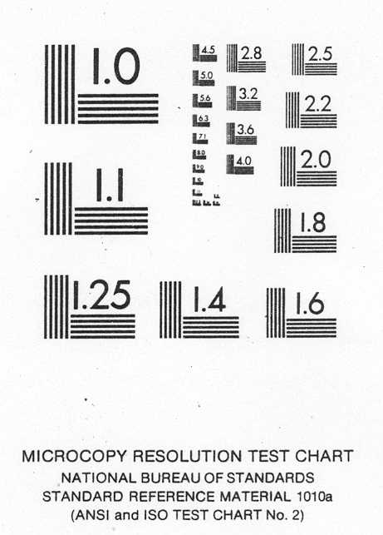

Image Processing System

Certificate of Authenticity

(Non-Destruction of Public Records)

This is to certify that the digital images appearing on this roll of microfilm are complete and accurate reproductions of the original records and have been digitally imaged in the normal course of governmental affairs. They meet the requirements of the State Records Committee concerning the Image Processing of Public Records (N.J.S.A. 15:3-4).

Authorization:
 |  |  |  | Image Processing System Certificate #
 | Date |  |  | Signature of Custodian

For microfilm creator use
 | Date |  |  | Signature of Imaging Supervisor
 |  |  |  | Signature of Equipment Operator

Image Processing System

Certificate of Authenticity

(Destruction of Public Records)

This is to certify that the digital images appearing on this roll of microfilm are complete and accurate reproductions of the original records. They meet the requirements of the State Records Committee concerning the Image Processing of Public Records (N.J.A.C. 15:3-4).

The destruction or disposition of the paper records appearing on this roll is only to be accomplished after certification of this Image Processing System by the State Records Committee, and after inspection of the microfilm to insure completeness of coverage.

Authorization:
 |  |  |  | Image Processing System Certificate #
 | Date |  |  | Signature of Custodian

For microfilm creator use
 | Date |  |  | Signature of Imaging Supervisor
 |  |  |  | Signature of Equipment Operator

Image Processing System

Title Target

TITLE OF RECORDS:
FIRST RECORD:
LAST RECORD:
FILM CREATED FOR (AGENCY):
REDUCTION RATIO:
FILM TYPE:
TYPE OF EQUIPMENT:
(utilized to create microfilm from digital images)
EQUIPMENT NUMBER:

ROLL Identification #

Image Processing System

EQUIPMENT OPERATOR’S CERTIFICATE

CREATION DATA
DATE OF FILM CREATION: |  |  |  |  |  |  |  | ROLL Identification #:
FILM CREATED FOR (AGENCY):
TITLE OF RECORDS:
EQUIPMENT #: |  |  |  |  |  |  | NUMBER OF IMAGES:

INDEXING DATA
BEGINS WITH:
ENDS WITH:
MISSING DOCUMENTS (if needed)
Microfilm of the above digitally imaged records was created by (name of agency):
I hereby certify that the images of the records appearing in this roll of film are true and accurate copies of the original documents described above.
 |  |  |  |  |  | Signature of Equipment Operator

Image Processing System

END RESOLUTION Target

Image Processing System

END BACKGROUND DENSITY Target

